NM ASSIGNMENT 2

Done By Thulasiraj M

# Data Set Link: [Human Resources Data Set (kaggle.com)](https://www.kaggle.com/datasets/rhuebner/human-resources-data-set)

**Step 1 : Create a new data module from the uploaded CSV file for visualizing data.**

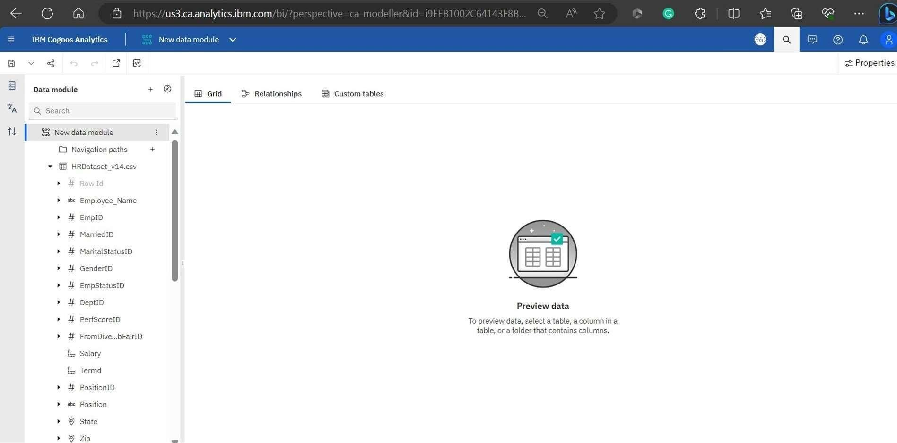

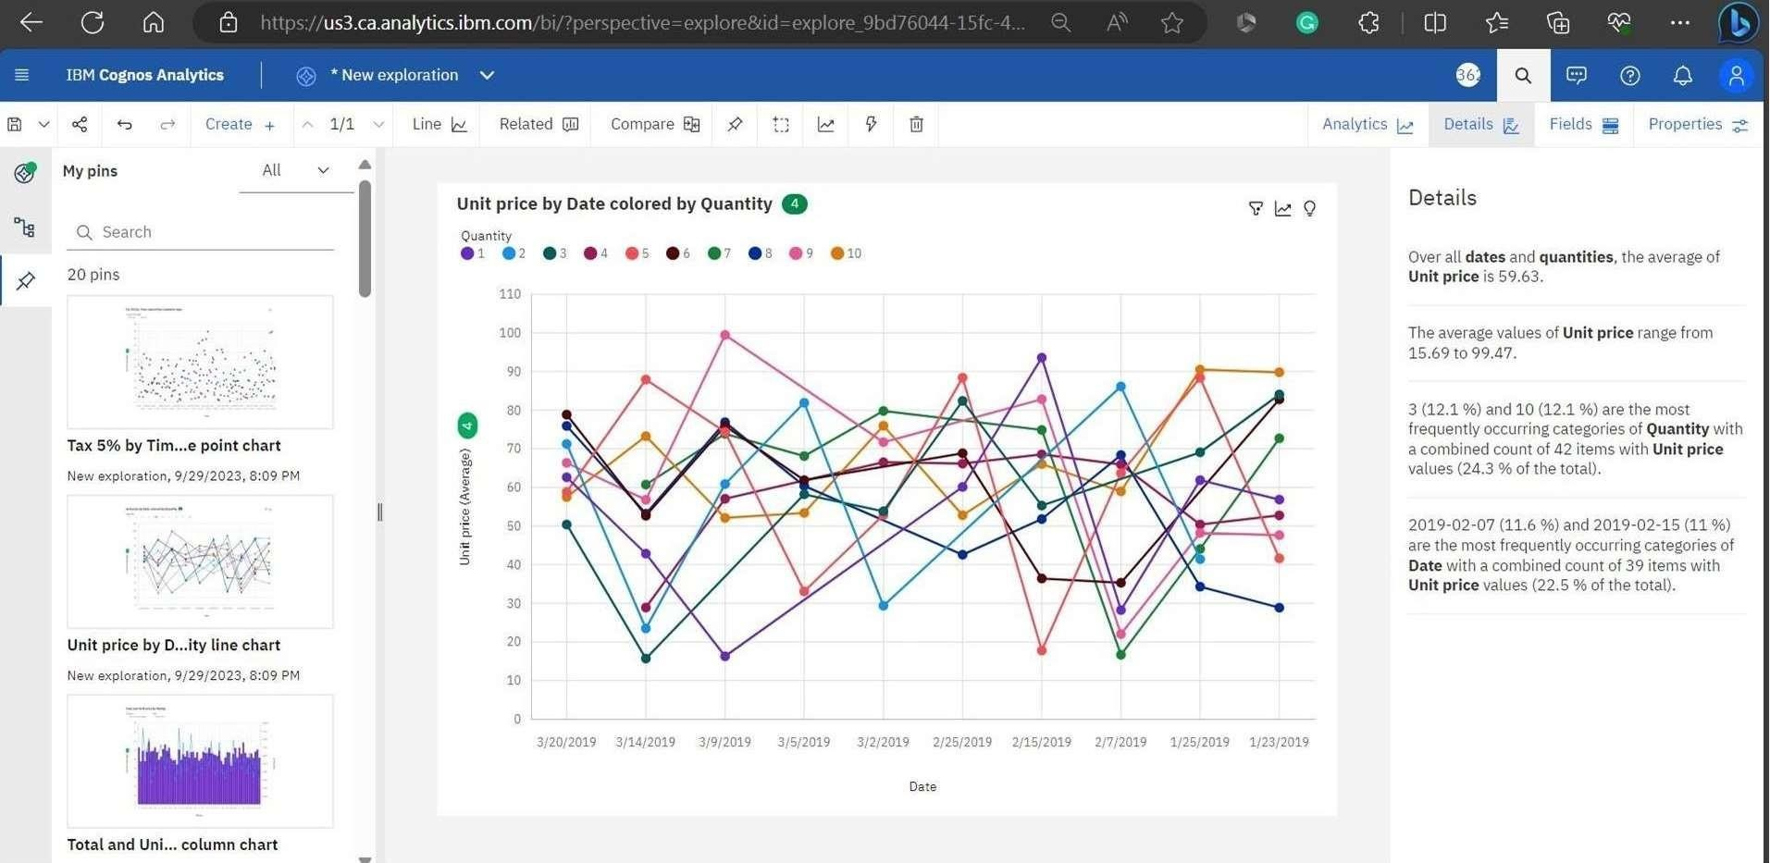**Step 2 : Using data module , create more explorations and pin it.**

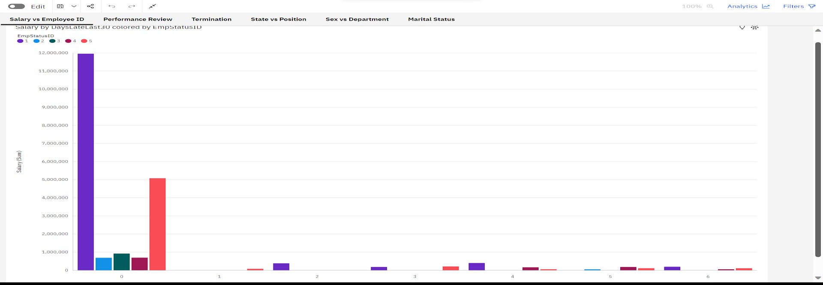**Step 3 : Using the pins, create Dashboard**

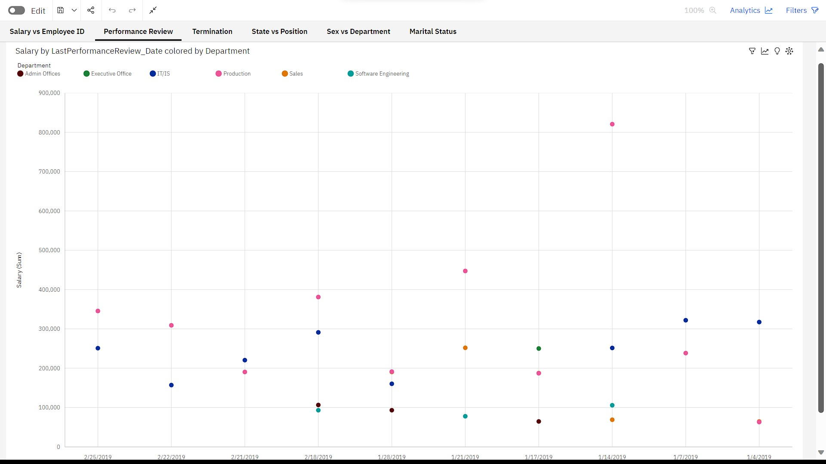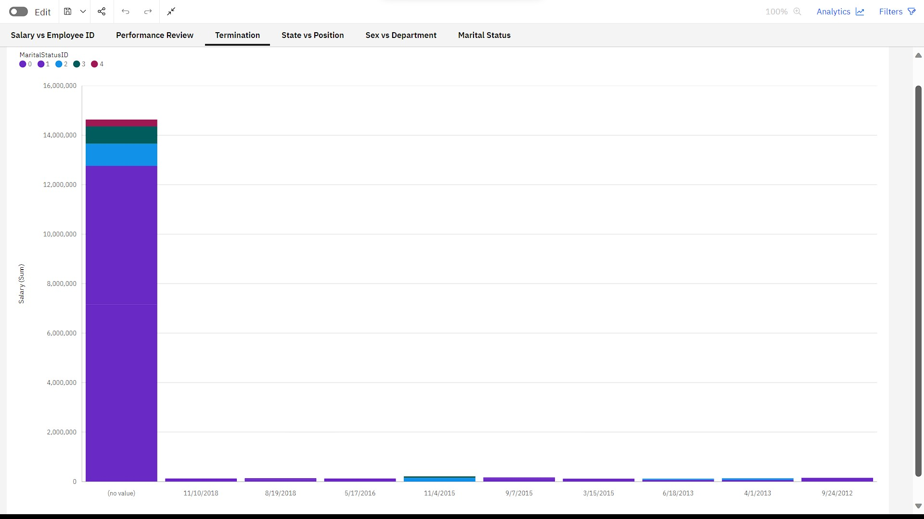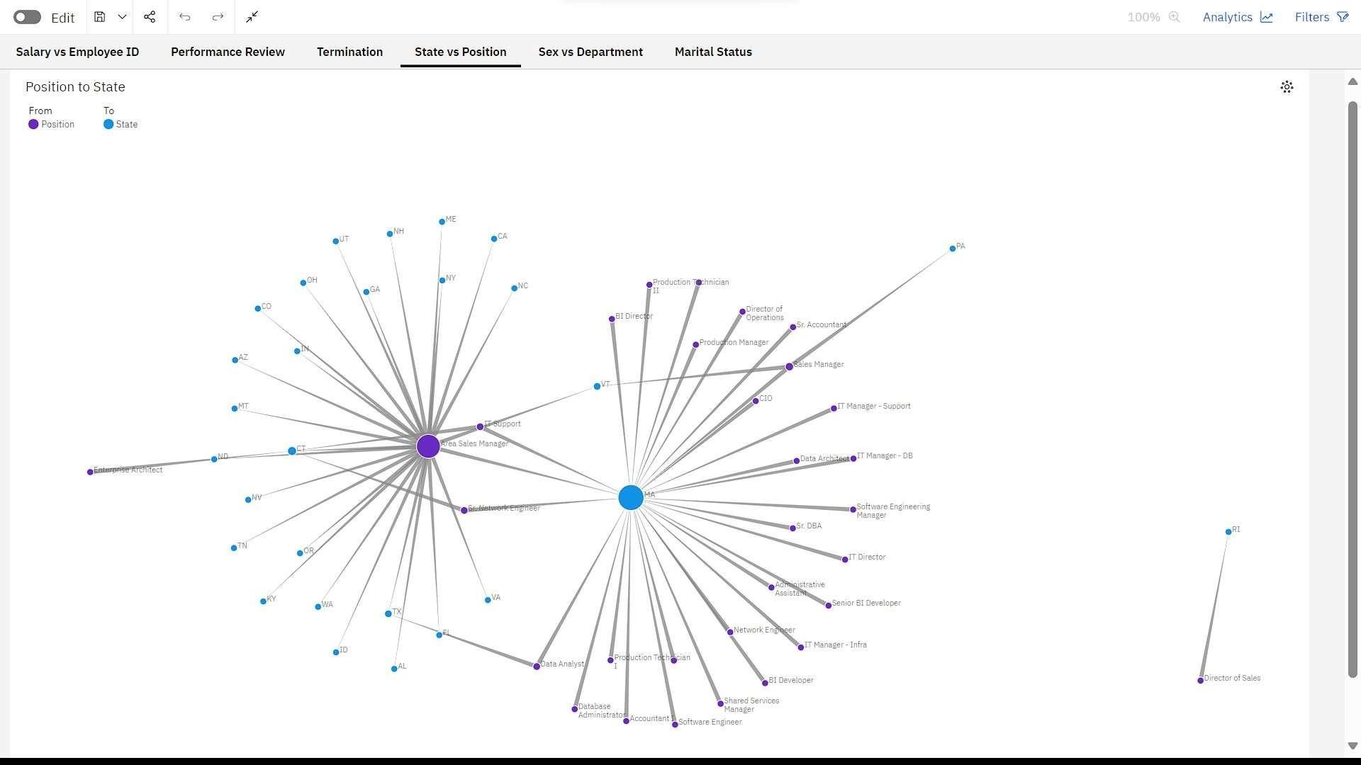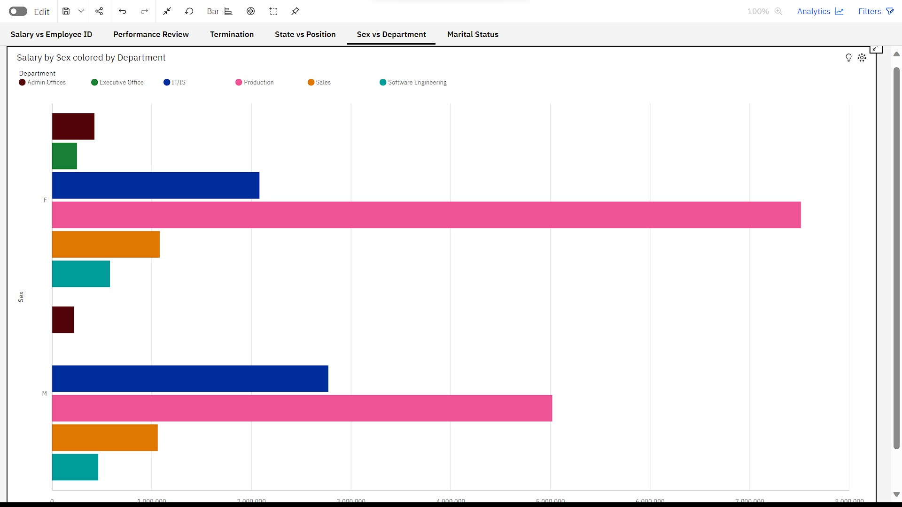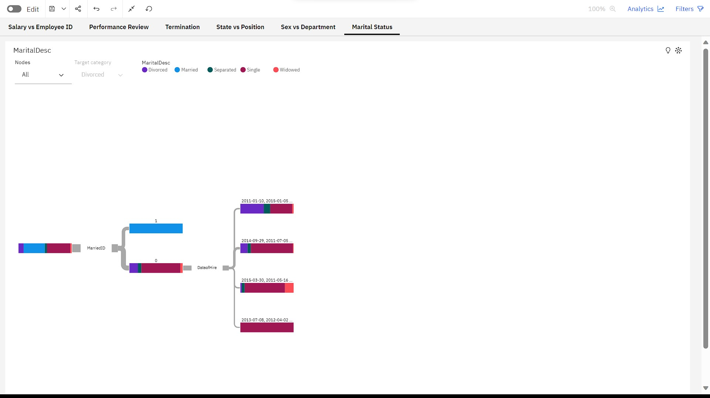

**Step 4 : After done with that dashboard, Now create a report.**

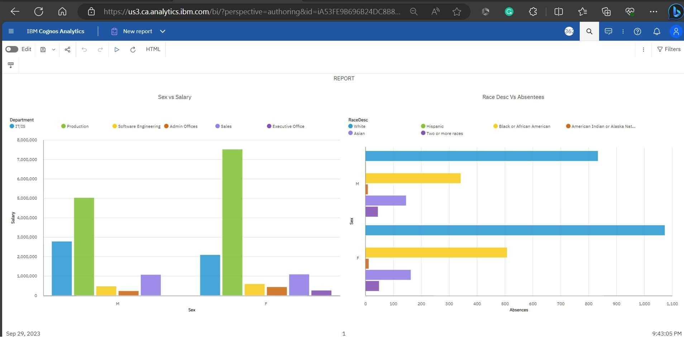

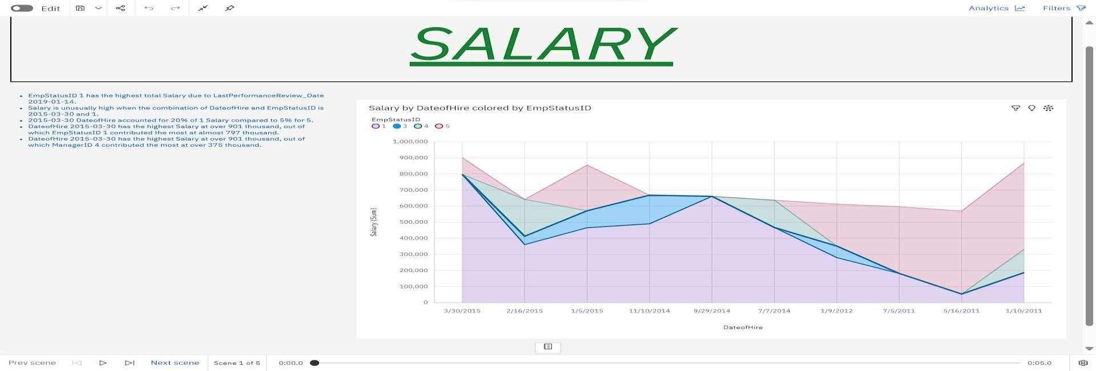**Step 5: After done with that report, Create a story to view our visualizations in the form of slides.**

